2018 ICMJ Careers Expo
“Careers along the red meat supply chain”

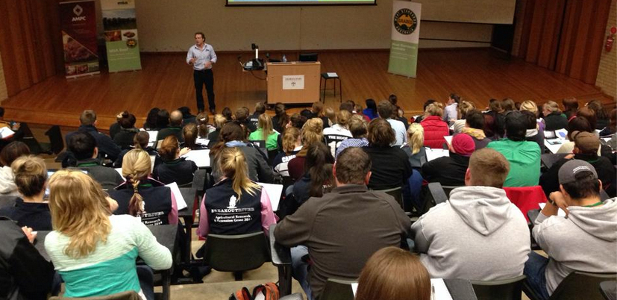
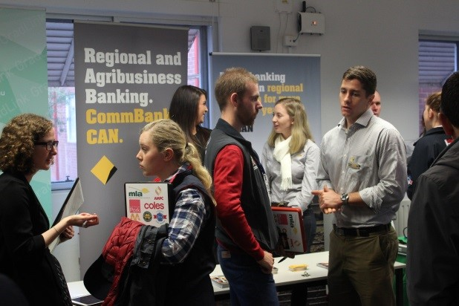
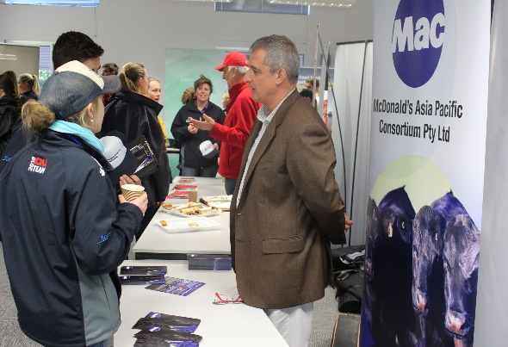

Showcase your company or career to over 150 undergraduates who
are passionate about the meat and livestock industry

8:30am – 12:30pm, Friday 6th July 2018
Charles Sturt University, Wagga Wagga
FREE to all exhibitors
FREE company profile in each student pack

Are you seeking keen and educated graduates to employ?
Or do you have an interest in retaining young people in our
meat and livestock industry?
This is your chance to capture the attention and interest of over 150 University
students, studying agri-business as well as agricultural, animal and veterinary
science degrees, from all over Australia.

Proudly sponsored by:
For more information contact:
Rozzie O’Reilly – ICMJ Careers Expo Coordinator
icmjcareers@gmail.com
0427 226 625
www.icmj.com.au

Would you like to be a participant at the 2018 Meat & Livestock Industry Careers Expo?

Please complete the following details and email to: icmjcareers@gmail.com

1. Company name:

2. Company location:

3. Number of attendees at Careers Expo:

4. Will you be providing information (i.e. booklets, brochures etc.) to go into student information packs – please note there will be 160 packs.

Yes |  | No

5. Please provide a brief summary of your company to go into a Careers Expo brochure.

6. Contact details for confirmation:

Name:

Email:

Phone:

Further information
- Each company will be provided with a trestle table
- There will be adequate space for your own pull up banners/signs
- The Careers Expo will run in rotation with other ‘career & professional development workshops’. This will provide each company time to have greater one-on-one time with students as they rotate in 4 groups.
- Set up will commence at 8:00am
- Upon registration, confirmation details will be forwarded to the contact listed above.

